**QUE-9.5- Explain the running modes of pig and integrate Tez with Hadoop and run a simple pig query using tez.**

**ANS-9.5-**

**RUNNING MODES IN PIG-**

**1. MapReduce/Hadoop Mode-**

-Here Pig jobs run as a series of MapReduce jobs picking the input and output paths from HDFS.

-Input file has to be copied in HDFS in case of Map reduce mode. Type the command pig or pig –x mapreduce to run Pig in MapReduce Mode.

**2. Local Mode-**

-Here the entire Pig job runs as a single JVM picking the localUnix path for execution.

-Input file has to be kept in local file system in case of local mode.

-Type the command pig or pig -x local to run Pig in Local Mode.

**DATASET-**

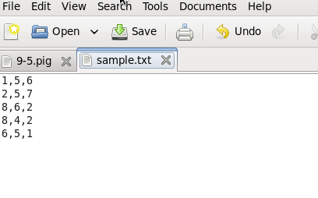

**PROGRAM-**

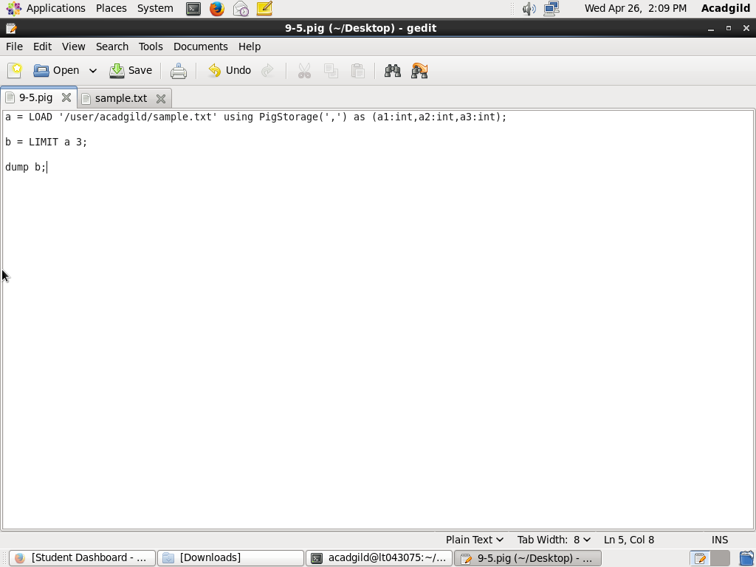

**EXECUTION COMMAND-**

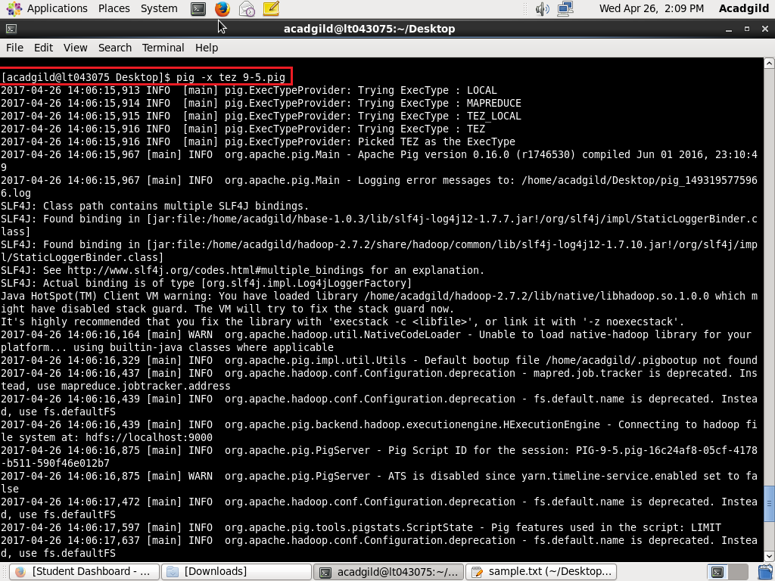

**OUTPUT-**

